Title
First Name First Surname-Second Surname ¹, First Name First Surname-Second Surname ² and First Name First Surname-Second Surname ^{2,*}
¹ Laboratory, Department, Institution, City, State, Country (First Author)
² Laboratory, Department, Institution, City, State, Country (Second Author)
* Corresponding author: e-mail@mail.com; Tel.: optional, including country code; ORCID: 0000-0000-0000-0000

Received: Accepted: Published:
DOI: To be assigned by the editorial team.
Abstract: Provide a single-paragraph summary of the work, with a maximum length of 300 words. The abstract should briefly present the background, objective, methodology, main results, and conclusions of the study.

Keywords: keyword 1, keyword 2, keyword 3, keyword 4, keyword 5
(Provide 3 to 5 keywords specifically related to the paper. Do not repeat words already used in the title unless strictly necessary. Separate keywords with semicolons)
How to use the template (This section must be deleted at the end of writing the paper).
- The paper must be submitted as a Word file (extension: DOC or DOCX).
- The template contains all the required sections, as well as the font styles to be used.
- The font styles for each part of the document are defined in the Word tab: Format > Style... (e.g. REB&S_authors).
- Each section contains the title and a brief description of the content (this description should be removed when the paper is written).
- If you have any questions, please send an email to: secretariat@aldeser.org
Introduction
The introduction should briefly describe the problem addressed in the paper, place the study within its broader scientific context, and explain its relevance. It should also include a concise review of previous research directly related to the topic and clearly state the novelty, objective, and contribution of the study. All sources cited in the text must be included in the reference list.
Materials and Methods
Describe the materials and methods used in the study. For new methods, describe them in detail and for well-established methods, describe them briefly and cite the original source.
Subsections
Use the corresponding subsection style for subsection headings within the text.
Subordinate section
Any subordinate section included under a subsection must follow the format established in this template.
Results and Discussion
This section should present the main results clearly and precisely, followed by their critical interpretation in relation to previous studies and the objectives or hypotheses of the work. Authors should emphasize the scientific relevance of the findings, identify limitations when appropriate, and suggest possible directions for future research.

Equations must be inserted using the Word equation editor and numbered consecutively throughout the manuscript.
In the text, equations should be cited as Equation 1, Equation 2, etc.

$$XXX=\frac{XXXXXX}{XXXXXX}$$ | (1)

Equation example:
$$C_{t;biogas}= C_{0;biogas} (1 - e^{k_{biogas }t})$$ | (1)

where: C_{t;biogas} (L/kg TS; L/kg VS) is the cumulative biogas yield at digestion time t (days); C_{0;biogas} (L/kg TS; L/kg VS) is the maximal biogas yield; and k_{biogas} (d⁻¹) is the kinetic coefficient of biogas production.

Figures and tables should be cited in the text as Figure 1, Table 1, etc.


Figure X. Title of the figure. Provide a clear and concise description of the figure. Define all symbols, abbreviations, and units used. If applicable, include the source citation following the reference style of the journal.
Table X. Title of the table.
Title 1 | Title 2 | Title 3
Variable 1 | data | data
Variable 2 | data | data
Variable 3 | data | data
Note. Provide a general description of the table's content. Define all abbreviations (e.g., SD = standard deviation; CI = confidence interval). If applicable, include the source citation following the journal format.
ᵃ Insert a specific note for a particular cell, row, or column here.
ᵇ Insert another specific note if needed.
* p < .05.
** p < .01.

Other cases for example (Figure 2).

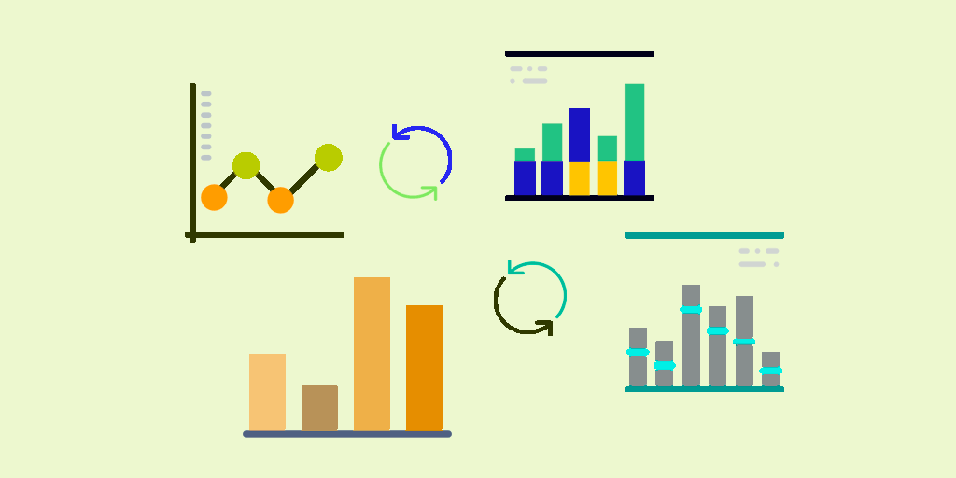 | 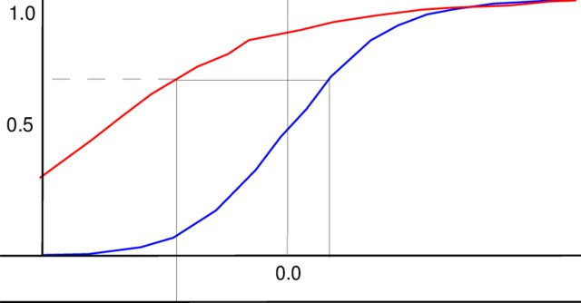
(a) | (b)
Figure X. Caption for a composite figure. Describe each part in sequence: (a) description of panel a; (b) description of panel b.
Conclusions
Include the main conclusions of the paper.

The following sections must be included after the Conclusions section. Conflicts of Interest and Author Contributions are mandatory. The remaining sections (Acknowledgments, Funding, Ethics Statement, and AI Use Disclosure) must be included when applicable. If not applicable, indicate: Not applicable.

Acknowledgments: Include acknowledgments to individuals, institutions, or organizations that contributed to the work but do not meet the criteria for authorship.

Funding: Provide complete information about the financial support received for the study, including the funding agency, project number, and grant identifier, when applicable. If the study did not receive external funding, indicate: This research received no external funding.

Conflicts of Interest: The authors must declare any financial, professional, or personal relationships that could be perceived as influencing the results or interpretation of the manuscript. If there are no conflicts of interest, indicate: The authors declare no conflicts of interest.

Ethics Statement: If applicable, provide the name of the approving ethics committee or institutional review board, the approval number, and the date of approval. For studies involving humans, animals, or sensitive biological materials, authors must confirm compliance with the corresponding ethical standards. If not applicable, indicate: Not applicable.

AI Use Disclosure: If artificial intelligence tools were used during the preparation of the manuscript, authors must disclose the tool used and its specific purpose (e.g., language editing or readability improvement). AI tools cannot be listed as authors and must not be used to generate scientific hypotheses, perform critical analysis, interpret results, or draw conclusions. Authors remain fully responsible for the accuracy, integrity, and scientific validity of the work. If no AI tools were used, indicate: The authors declare that no artificial intelligence tools were used in the preparation of this manuscript. If not applicable, indicate: Not applicable.

Author contributions: Include the specific contribution of each author using initials. Use the following roles when applicable: Conceptualization, Methodology, Formal analysis, Investigation, Data curation, Writing – original draft, Writing – review & editing, Supervision, Project administration, Funding acquisition, Resources, and Validation.

Use the following format:
A.P.-G.: Conceptualization, Investigation, Writing – original draft; B.C.-D.: Methodology, Formal analysis, Writing – review & editing; D.M.-B.: Resources, Supervision.

Only include the roles that apply to the manuscript.
References
References must follow APA (adapted) format. List all references in alphabetical order by the first author's surname. Do not use bullets or numbering. Do not leave blank lines between references. Apply a hanging indent from the second line of each reference. Preserve the original language of each source. Use italics for journal names, volume numbers, and book or thesis titles. URLs must be included on the same line without "Retrieved from".

Example to cite a journal paper
Yoo, J. J., Seo, G., Chua, M. R., Park, T. G., Lu, Y., Rotermund, F., Kim, Y., Kim, H., Kim, J., Kim, S., & Seo, J. (2021). Efficient perovskite solar cells via improved carrier management. Nature, 590(7847), 587–593. https://doi.org/10.1038/s41586-021-03285-w

Example to cite a book
Mathew, S. (2006). Wind energy: Fundamentals, resource analysis and economics. Springer.

Example to cite a book chapter
Chandel, S. S., & Sharma, A. (2022). Recent advances in solar photovoltaic technologies. In S. Singh (Ed.), Renewable energy systems: Modeling, optimization and control (pp. 3–35). Academic Press.

Example to cite a thesis
Pabón Pereira, C. P. (2009). Anaerobic digestion in sustainable biomass chains [Doctoral thesis, Wageningen University]. https://library.wur.nl/WebQuery/wda/1910420

Example to cite a report or web document
United Nations Environment Programme. (2023). Emissions Gap Report 2023: Broken Record – Temperatures hit new highs, yet world fails to cut emissions (again). https://www.unep.org/interactives/emissions-gap-report/2023/

Ensure that every in-text citation has a corresponding entry in the reference list and that every reference listed has been cited in the text. Authors are responsible for the accuracy, completeness, and formatting of all references.

In-text citations must follow the author–date format.

Single author: (Smith, 2020)
Two authors: (Smith & Johnson, 2021)
Three or more authors: (Smith et al., 2022)

Narrative citation: Smith (2020) reported that…
For two authors in narrative form: Smith and Johnson (2021) reported that…
For three or more authors in narrative form: Smith et al. (2022) reported that…

Multiple citations: (Smith, 2020; Johnson, 2019; Lee et al., 2021)

Same author and year: (Smith, 2020a, 2020b)

In in-text citations, use "&" when citing within parentheses (e.g., Smith & Jones, 2020) and "and" when the authors are part of the narrative (e.g., Smith and Jones (2020)). In the reference list, always use "&" before the last author.

